Lab2 Report

Lab group members: Yen-Jung(Tim) Lu, Xingting Peng, Hugo Muro Avila

**Introduction:**

This lab is built to let students familiarize with the Altera Quartus design program,

students would need to design a schematic, and simulate the circuit in the Quartus

program.

**Prelab Results:**

Truth Table:

| S | M1 | D | L | A |
| --- | --- | --- | --- | --- |
| 0 | 0 | 0 | 0 | 0 |
| 0 | 0 | 1 | 0 | 0 |
| 0 | 1 | 0 | 1 | 0 |
| 0 | 1 | 1 | 0 | 0 |
| 1 | 0 | 0 | 1 | 0 |
| 1 | 0 | 1 | 1 | 0 |
| 1 | 1 | 0 | 1 | 1 |
| 1 | 1 | 1 | 1 | 0 |

Tim: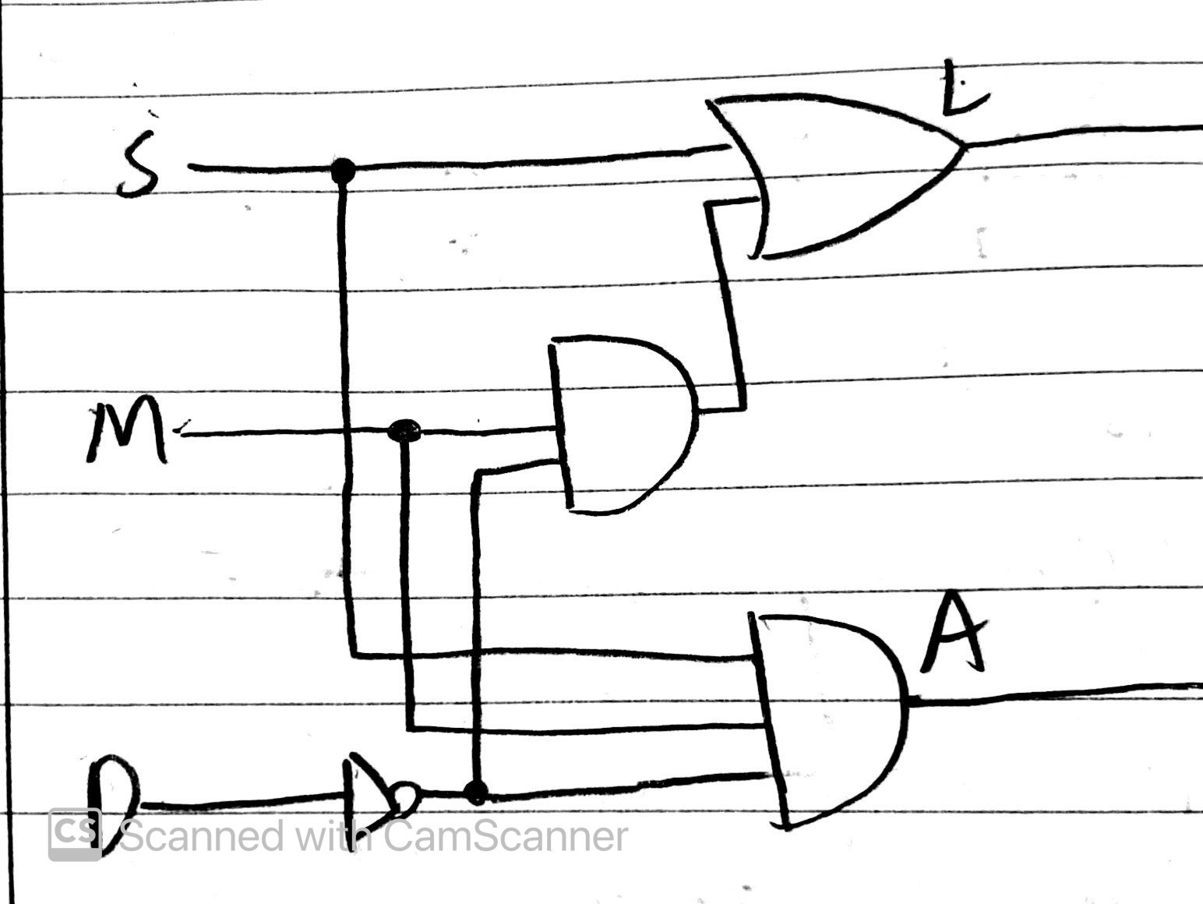

Hugo:

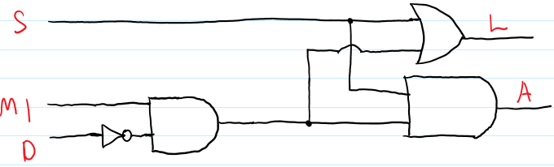

Xingting Peng:

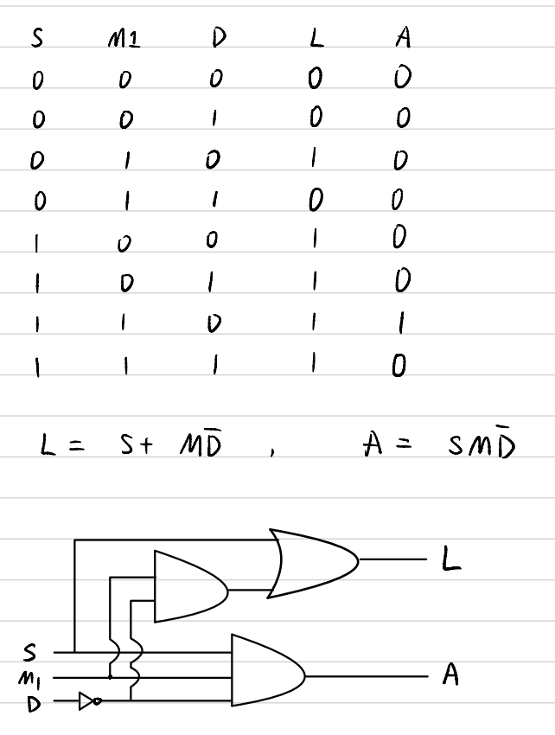

**Procedure:**

After opening the program and starting a new schematic file, we first started by adding the necessary components: including inputs and outputs, as well as AND, OR, and NOT gates. After placing these components into the program, we wired each of them to their appropriate connections, according to what we did in the prelab.

After that was done, we ran the program to ensure that no errors were found by the compiler. When we were able to confirm that the compiler found no errors and the program was operating correctly, we proceeded to import the assignments.

After compiling the circuit, we need to download the DE2_115.qsf assignment from

Camino, and import the assignment in the program. We would need to implement another compilation after we import the assignment in the program. Fix the error, if there is something wrong with the circuit.

As long as we debug all the errors, we need to use the programmer in the toolbar to connect the program to the circuit board. We would need to use the switches and LEDs on the circuit board to test the function of our design in the circuit.

Tim:

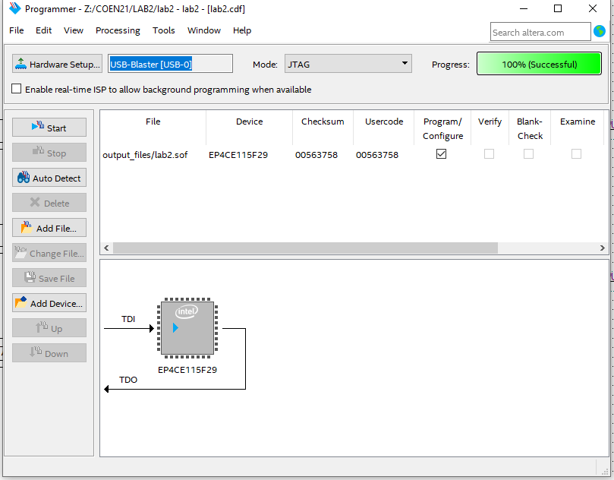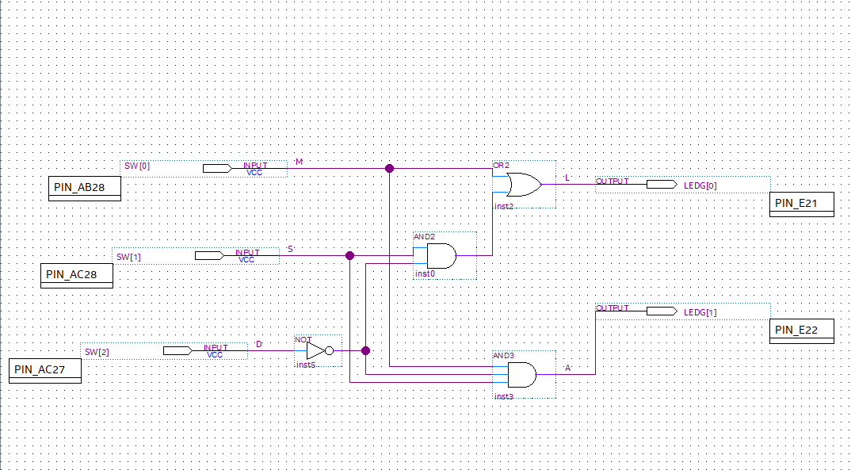

Hugo:

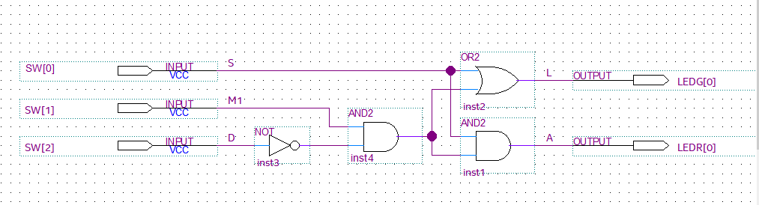

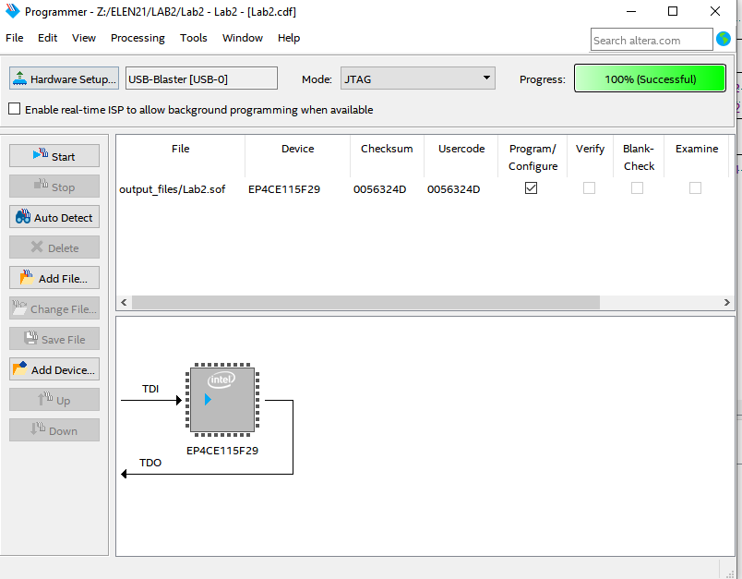

Xingting Peng:

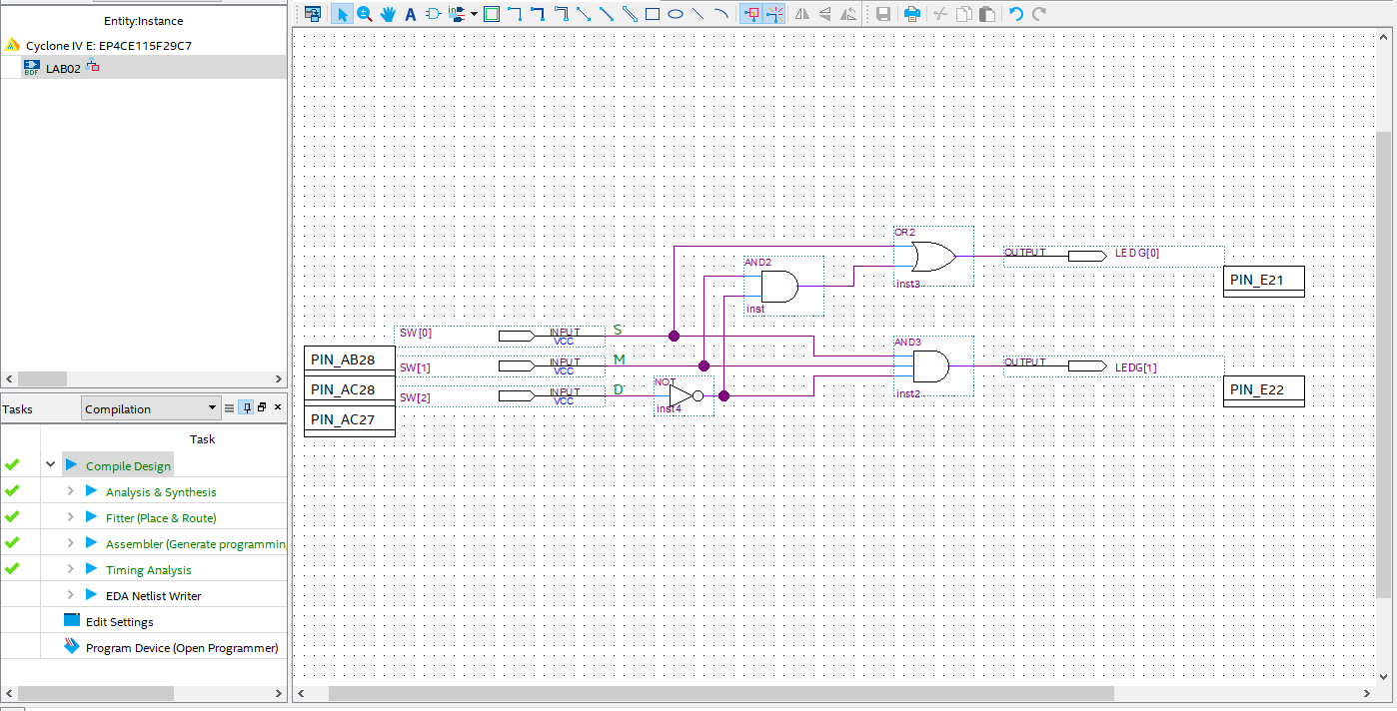

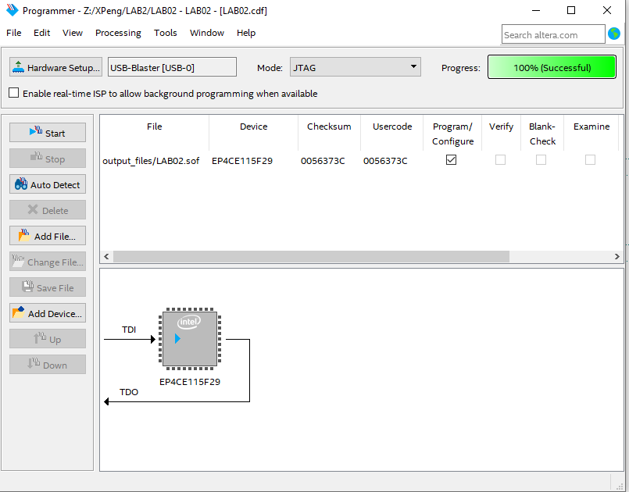

*Questions:*

1. In Laboratory 1, what would you have had to change to use three motion detectors such that any of three different motion detectors could turn on the light and could also turn on the buzzer if the light were already on because the manual switch S was on? Specifically consider the component changes or additions, the wiring changes, and the testing.

Potentially: Instead of having the original motion detector wired into the inputs of the AND and OR gate, we would have three motion detectors go into a new, three way OR gate, which would then be wired to the AND and OR gate as before. When testing, you would check to make sure that as long as one of the motion sensors is on, the system would respond as before, when it was just one.

1. Compare that to the changes you would need to make for the Altera FPGA

implementation of a logic circuit using three motion detector inputs.

We would need to add an OR gate which has three motion detectors as the inputs, and connect this OR gate directly to the OR and AND gates in the lab1’s circuit. Also, we would need to set up three switches on the circuit board to connect to the three motion sensors as the inputs.